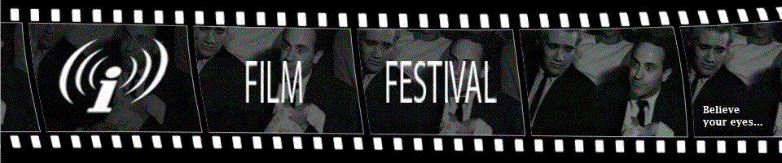
CALL FOR ENTRIES!
IMC Film Fest 2010 February 5-7, 2010

SUBMITTAL FORM, Urbana Champaign Independent Media Center (IMC) Film Festival 2010
Film Title:
Director Producer:
Writer:
Year Completed: Running Time:
Category: (E.g. documentary, experimental, narrative, comedy, etc.):

Print Source (for program):
Contact Name:
Company:
Street Address:
City, State, Zip:
Phone:
Email/Website:
Director’s Contact Info:
Name:
Company:
Street Address:
City, State, Zip:
Phone:
Email/Website:
May the IMC retain your film for our archives? _____Yes _____No
May the IMC use clips of your film for promotional purposes? _____Yes _____No
I have read and agree with the submittal guidelines. Furthermore, I certify that I am authorized to submit this film/video to the IMC Film Festival.
Signature: _______________________________________________________________________

SUBMITTAL GUIDELINES:
DEADLINE:
Entries must be received by January 15, 2010.
SUBMITTAL FORM:
Submission is free. Submittal Form must be filled out and signed for films to be considered. Please mail a copy of your submittal form and film submission, in standard DVD format, to:
IMC Film Fest
Urbana-Champaign Independent Media Center
202 S. Broadway Ave
Suite 100
Urbana IL 61801
217-344-8824
MEDIA KITS:
At least one digital image, with each entry, is highly recommended. Bios, press, etc. are also recommended.
CONFIRMATION:
Please email imcffprogramming@gmail.com letting us know that you have mailed your submission. We will notify you upon receipt, or let you know if we do not receive it within the expected timeframe.
OTHER CONTACT INFO:
For sponsorship & to volunteer, contact: Nicole.Pion@gmail.com
For workshops, contact: Katyvizdal@gmail.com

